**Department of Information Technology, ABESEC, Ghaziabad**

**IT2021-22_P25**

Project (KIT-753) Approval Form

B. Tech. Final Year Project (Batch 2021-22)

**Details of Student**: Credits-4

|  |  |  |  |  |  |
| --- | --- | --- | --- | --- | --- |
| S. No. | Names | Roll Numbers | Aggregate % | Mobile | Email |
| 1 | Vanshika | 1803213166 | 75% | 7017558992 | [vaanshikarathi@gmail.com](mailto:vaanshikarathi@gmail.com) |
| 2 | Vanshika Singh | 1803213167 | 82% | 6397849873 | [vanshika.18bit1195@abes.ac.in](mailto:vanshika.18bit1195@abes.ac.in) |
| 3 | Sanjay Kumar | 1803213128 | 74% | 9616410411 | [sanjay.18bit1109@abes.ac.in](mailto:sanjay.18bit1109@abes.ac.in) |
| 4 | Sanidhya Jain | 1803213127 | 77% | 6387224676 | [sanidhya.18bit1110@abes.ac.in](mailto:sanidhya.18bit1110@abes.ac.in) |

**Project Domain: AI, ML, Deep Learning**

**Title of Project: Customer Behavioral Analysis**

**Project Objective:**

1. **Developing Front End of the Project for video and image processing [7th Sem]**
2. **Developing Back End of the Project for video and image processing [7th Sem]**
3. **Developing Machine learning and AI of the Project for video and image processing [7th Sem]**
4. **Adding Front End part of the voice recognition module. [8th Sem]**
5. **Developing Back End part of the voice recognition module. [8th Sem]**
6. **Connecting Machine learning and AI for voice recognition module.[8th Sem]**

**Brief Description about project:**

**Customer Relationship Management using Real Time Face Emotions Detection and Voice Recognition application using machine learning and AI. In phase 1 we will develop the desktop compatible website of the module which can be used while online video conferencing. This project will work on two major inputs i.e on facial data of the person and the vocal tone of the person. Based on the type of data provided the module will work on different scales to render the expressions of the customer, as a result it will analyze and detect the mood and behavior during the meetings. And in future in phase 2 we will add the recommendations of the activities which the dealer can perform in runtime to make the deal successful with the customer. Also we will plan to develop the Mobile compatible application for the same.**

**Language / Tools that may be used:**

**Python, HTML, CSS, JavaScript, PHP, BootStrap, Selenium library, Numpy, Pandas.**

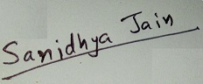 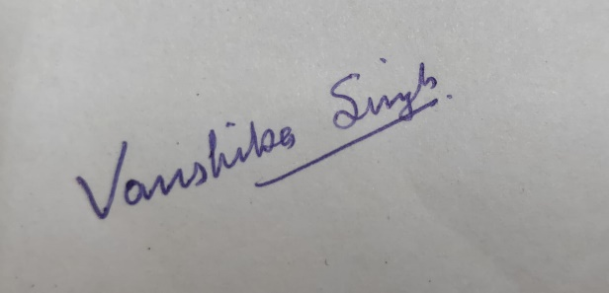

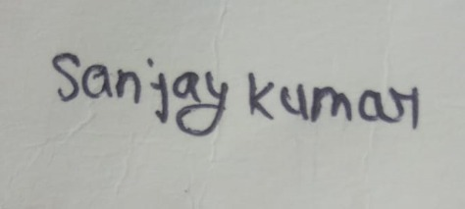 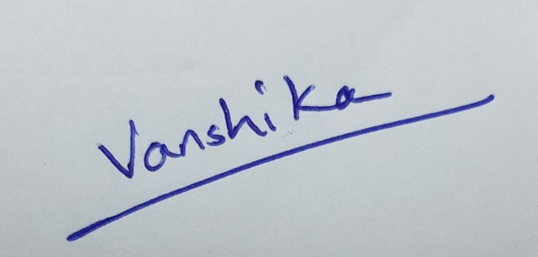

**Signature of students**

**Expected Outcomes:**

**It will be a live project once all the modules are developed and enhanced.**

**(Guide Name & Signature)**

**HOD’s Remark:** Approved / Approved with changes / Not Approved

**HOD’s Signature Date:**